FRACTALS-4

**Fractal and multifractal time series**

Fractal and multifractal temporal series exhibit fluctuations on a wide range of time scales and/or broad distribution of the values. These fluctuations follow scaling laws and are described by one or by a hierarchy of scaling exponents that characterize the underlying stochastic processes. Although these processes usually are not known in details, fractal and multifractal analysis can serve to distinguish between different systems or between different states of the same system as well as in validation and improvement of existing models.

Fractal and multifractal analysis of time series were successfully applied on physiological, ecological, geophysical, climatic and financial data.

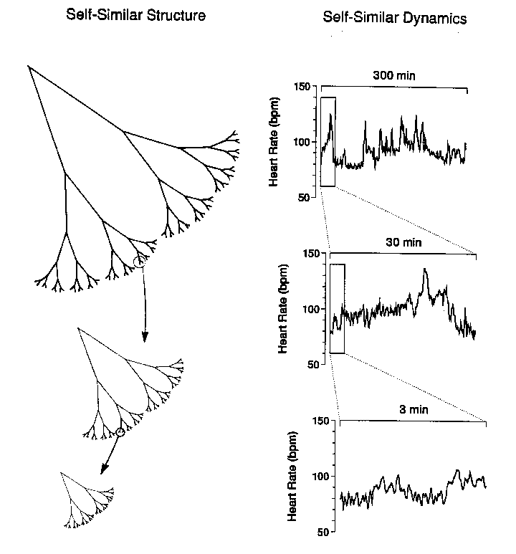

Figure 1. Left, schematic of a tree-like fractal has self-similar branching such that the small scale (magnified) structure resembles the large scale form. Right, a fractal process such as heart rate regulation generates fluctuations on different time scales (temporal "magnifications") that are statistically self-similar [1].

**Self-affine time series**

A time depended process is self-similar if

 (1)

where  means statistical equivalence of both sides of the equation. This type of process for which  axes (time) and  axes (the value of the time series) need to be rescaled with different factors (in order to exhibit self-similarity) is also called self-affine process. The exponent  is called the self-similarity parameter. Figure 2 (Adapted from PhysioNet: [www.**physionet**.org/](http://www.physionet.org/)) illustrates the concept of self-similarity for simulated random walk.

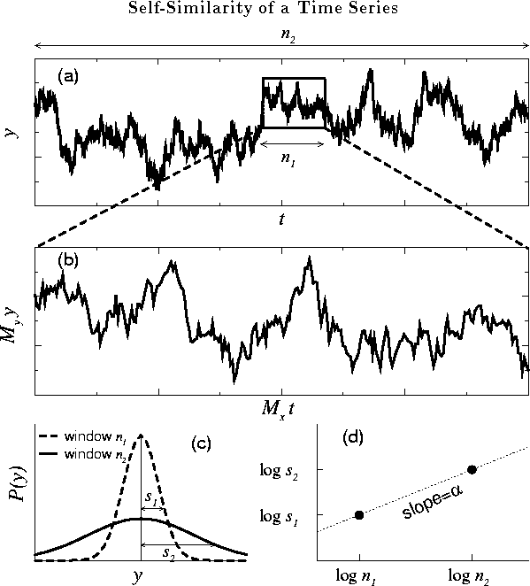

**Figure 2.** Illustration of the concept of self-similarity for a simulated random walk. (a) Two observation windows, with time scales  and , are shown for a self-similar time series . (b) Magnification of the smaller window with time scale . Note that the fluctuations in (a) and (b) look similar provided that two different magnification factors, and , are applied on the horizontal and vertical scales, respectively. (c) The probability distribution  of the variable  for the two windows in (a), where and  indicate the standard deviations for these two distribution functions. (d) log-log plot of the characteristic scales of fluctuations, , versus the window sizes, .

It is seen from Figure 2 that with the appropriate choice of scaling factors  and on the *x*- and *y*-axis respectively, the rescaled time series (Fig. 2b) resembles the original time series (Fig. 2a). The self-similarity parameter  defined in Eq. 1 can be calculated by

 (2).

The choice of scaling factors  and is illustrated in Figure 2. Two observation windows (Fig. 2a), window 1 with horizontal size   and window 2 with horizontal size , were arbitrarily selected and the goal is to find the correct magnification factors (along the horizontal and vertical direction) such that we can rescale window 1 to resemble window 2. It is seen from Fig. 2a that the magnification factor along the horizontal direction   For the magnification factor along the vertical direction, , we need to determine the vertical characteristic scales of windows 1 and 2. One way to do this is by examining the probability distributions (histograms) of the variable *y* for these two observation windows (Fig. 2c). A reasonable estimate of the characteristic scales for the vertical heights, i.e., the typical fluctuations of *y*, can be defined by using the standard deviations of these two histograms, denoted as (for window 1)  and , (for window 2) which gives  Substituting   and   into Eq. 2, we obtain 

 (3).

This relation is simply the slope of the line that joins points  and  on a log-log plot (Fig. [2](http://www.physionet.org/tutorials/fmnc/node3.html#f2)d).

For “real-world” time series, we perform the above calculations using the following steps: (1) For any given size of observation window, we divide the time series into subsets of non overlapping windows of the same size. To obtain a more reliable estimation of the characteristic fluctuation at this window size, we average over all individual values of *s* obtained from these subsets. (2) We then repeat these calculations for many different window sizes. (3)The exponent tex2html_wrap_inline1001 is estimated as a slope of a line on the log-log plot of *s* versus *n* across the relevant range of scales.

**Bibliography**

[1] A.L. Goldberger, Non-linear dynamics for clinicians: chaos theory, fractals, and complexity at the bedside, Lancet347, 1312-1314, 1996.